State Provided Growth Scores
This page from engageny is a great resource for teachers who want to know which students were included in their growth score component of their APPR. Please encourage your teachers to go in and check their results.
https://www.engageny.org/resource/resources-about-state-growth-measures

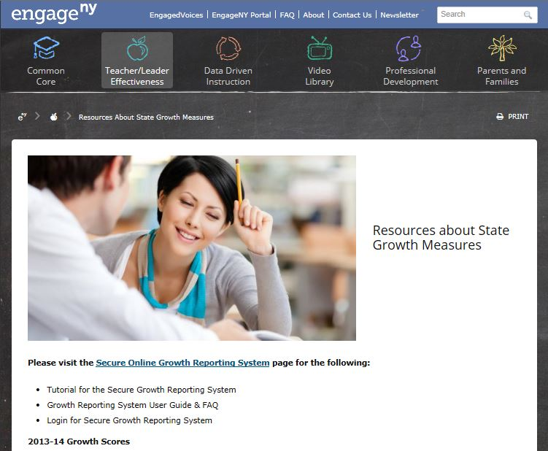

- Teachers select Secure Online Growth Reporting System

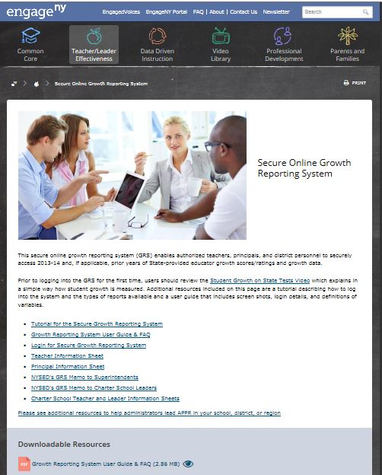

- Teachers should view the Tutorial, User ID & FAQ, and then Login

