SCREENING REPORT IN STAR

This report lets you look at a class and visually see who has reached the benchmark score as well as get a list of students in each category. You can also set STAR Reading and STAR Math to see who is on track for end of year state testing proficiency.

Log in to Renaissance Place (the home page for STAR)

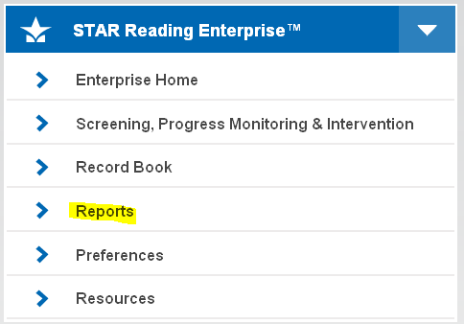
Go to the tab for the test you want to see results for. Click the word “Reports.”

On the next screen, choose the Screening Report

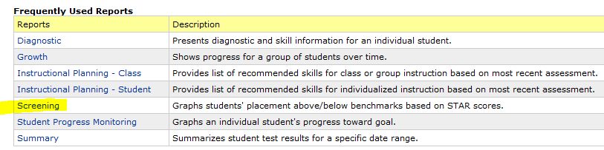

The next screen has the options for the Screening Report. Recommended settings and explanations are as shown in the arrows.

Select Students – Use the drop down arrow or click the word “Classes” to choose the class you want to see. Groups have to be set up before you view a report. Groups are helpful for Reading teachers or Consultant teachers. These can be set up on the Home Page by clicking on “Screening, Progress Monitoring and Intervention.”

Reporting Period – Make sure this is your testing window. An administrator can change this so it reflects the dates when you tested your students.

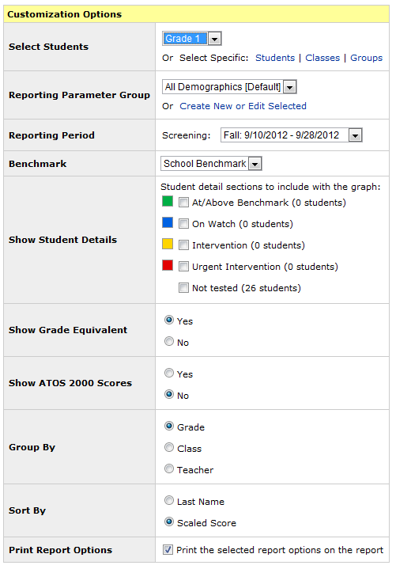

Is similar to a lexile score
Change to No
Check these boxes to see student names
Can be changed to NYSTP for NYS tests

When set to School or District Benchmark, the graph will show in green who has reached the benchmark setting (the default is the 40th percentile score nationally). The data just below the graph is helpful.

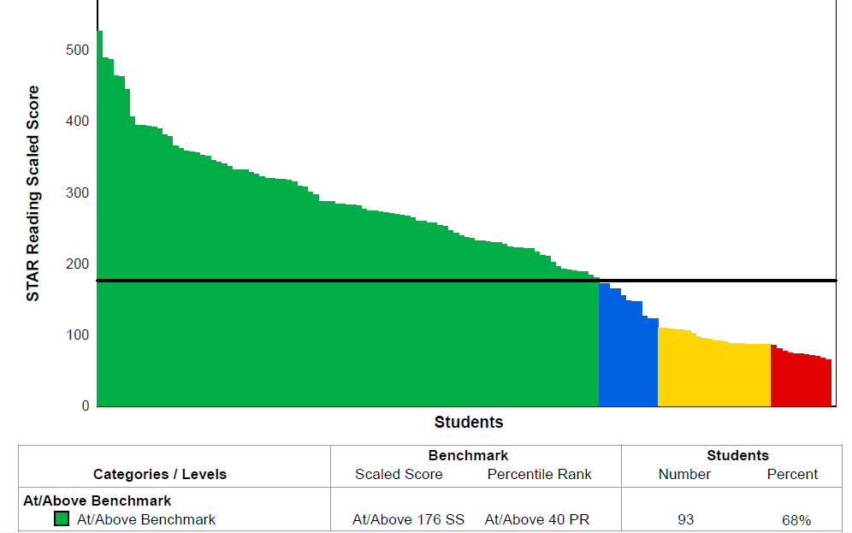
When set to NYSTP, Green represents students on track to score level 4, blue is level 3, yellow is level 2 and red is level 1 as seen below. This is based on older versions of our NYS tests. A new correlation should be done soon on the CCLS tests.

