Project Based Learning
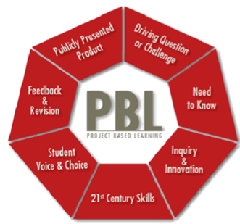

Project-based learning (PBL) is a dynamic approach to teaching in which students explore real-world problems and challenges. PBL includes:

- Learning that results in demonstrations of performance

- Real tasks that students solve

- Hands-on student directed activity in which students create something

- In-depth investigations of subject matter which are often guided by professional experts who enrich and supplement the teacher's knowledge

- More retention of knowledge

- Effective ways to integrate technology into the curriculum.

