Penny Boats
Posted on May 25th, 2013 by Mary Lord
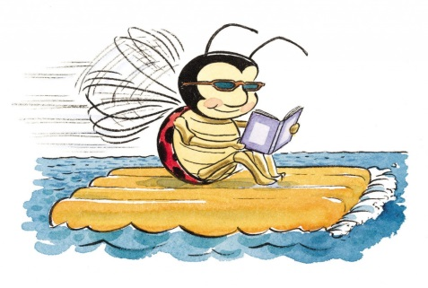
Lesson adapted from PBS’s Design Squad Nation, ©2012 WGBH Education Foundation.

Learning objectives
After doing this activity, students should be able to:
- Identify the tradeoffs between stability and buoyancy
- Understand the physical forces that cause objects to float or sink
- Understand the engineering design process and how to work in teams

Task: Design a boat out of straws and plastic wrap that can hold 25 pennies for at least 10 seconds before sinking.

Materials (per group):

- container filled with water (e.g., bucket, sink, plastic tub)
- .5 meter of tape
- paper cups (8-ounce or larger)
- 10-to 12-inch strip of plastic wrap (measurement doesn’t have to be exact)
- 6 straws (preferably non-bendable, but any kind will work)
- paper or notebook and pencil or pen, to sketch designs
- 25 pennies, to start

Procedure
Activity
- Design and build a boat out of simple materials such as straws, tape, plastic wrap, and cups that will hold a minimum of 25 pennies without sinking for at least 10 seconds. You have a fixed amount of time to complete this task.
  - My time allotment is: _______________________________

- Two items appear in front of you. Take turns with the items, each pushing them down into the water. Note your observations.
  - Observations:
Object #1 (small) | Object #2 (large)

  - Craft a summary statement about what it felt like to push EACH object down into the water and why:

_____________________________________________________________________

- Using your task description, and your experience with the objects, brainstorm possible ideas about how to make a boat that will hold the mass of 25 pennies. Brainstorm with words, pictures, or other items that will help actually construct a working model. Write/ draw those ideas below.
  - Brainstorming space

- Narrow your design by dividing choosing the design you feel will work best and build it.

- TEST the designs by first placing them in the water, and then adding one penny at a time, up to 25 pennies. The boat will be considered as reaching “Failure” if one of the pennies becomes submerged in the water. Record the results below:

Drawing of Design | # of Pennies | Keep the same/ Change

- Evaluate. Redesign, and retest until the boat is successful (floating all 25 pennies).

Challenge: Keep designing your boat to hold as many pennies as possible.

Presentation Requirements: Prepare a digital presentation that does the following:

Defines Buoyancy in your own words and provide 2 examples, from this experiment, that directly showcases where the concept of buoyancy was active (either successfully or unsuccessfully).

Calculate the mass of the items necessary for the trip. Calculate the ration of the pennies to the average size of a human being.

Show the dimensions of a version of your design that is large enough to hold one human and all of the items necessary to be at sea for 60 days.

Determine the appropriate materials that the structure will be made out of an why.

Your presentation should be 5 min. in length and produced using digital media.

Standards Accomplished with Penny Boats:
Common Core State Standards Anchor Standards for Language Arts
- Interpret words and phrases as they are used in a text, including determining technical, connotative, and figurative meanings, and analyze how specific word choices shape meaning or tone.
- Conduct short as well as more sustained research projects based on focused questions, demonstrating understanding of the subject under investigation.
- Write routinely over extended time frames (time for research, reflection, and revision) and shorter time frames (a single sitting or a day or two) for a range of tasks, purposes, and audiences.
ISTE Standards for Students in Technology
- Communicate information and ideas effectively for multiple audiences using a variety of media and formats.
- Plan strategies to guide inquiry
- Process data and report results
- Collect and analyze data to identify solutions and/or make informed decisions
- Use multiple processes and diverse perspectives to explore alternative solutions
- Understand and use technology systems
Common Core State Standards- Mathematics
- Recognize volume as an attribute of solid figures and understand concepts of volume measurement. (Grade 5)
- Solve real-world and mathematical problems involving area, volume, and surface area of 2- and 3-dimensional objects. (Grade 7)
Next Generation Science Standards
3-5-ETS1-1. | Define a simple design problem reflecting a need or a want that includes specified criteria for success and constraints on materials, time, or cost.
3-5-ETS1-2. | Generate and compare multiple possible solutions to a problem based on how well each is likely to meet the criteria and constraints of the problem.
3-5-ETS1-3. | Plan and carry out fair tests in which variables are controlled and failure points are considered to identify aspects of a model or prototype that can be improved.
New York State Science Standards:
- Buoyancy is determined by comparative densities

